# A

# PROJECT ON

**CHILD ADOPTION SYSTEM**

SUBMITTED IN

PARTIAL FULFILLMENT OF THE REQUIREMENT

FOR THE COURSE OF DIPLOMA IN ADVANCED COMPUTING FROM CDAC

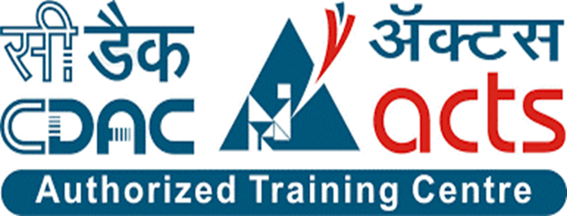

#### C-DAC Advanced Computing Training School ATC NETCOM,Jaipur,Rajasthan

**SUBMITTED BY**

|  |  |
| --- | --- |
| **PRN** | **NAME** |
| **210930920018** | **Bhushan Bhausaheb Gunjal** |
| **210930920030** | **Hrishikesh Natha Nalavade** |
| **210930920024** | **Snehal Jagdish Mahale** |
| **210930920016** | **Sandip Muralidhar Golekar** |

**UNDER THE GUIDENCE OF**

**Mr. BhanuPratap Singh**

Faculty Member

#### C-DAC Advanced Computing Training School ATC NETCOM,Jaipur,Rajasthan

**AT**

#### C-DAC Advanced Computing Training School ATC NETCOM,Jaipur,Rajasthan

**CERTIFICATE**

This is to certify that the project work under the title ‘Web Portal for Student and teacher’ is done byBhushan Gunjal, Hrishikesh Nalavade, Sandeep Golekar, Snehal Mahale

in partial fulfilment of the requirement for award of Diploma in Advanced Computing Course.

**Mrs. Prajakta Patil**   **Mr. Bhanu Pratap Singh**

**Project Guide Course Coordinator**

**Date:**

**ACKNOWLEDGEMENT**

A project usually falls short of its expectation unless aided and guided by the right persons at the right time. We avail this opportunity to express our deep sense of gratitude towards Mr. Nishant Singh (Center Coordinator, NETCOM, Jaipur) and Mr. Bhanu Pratap Singh Sir (Course Coordinator,NETCOM, Jaipur). We are deeply indebted and grateful to them for their guidance, encouragement and deep concern for our project. Without their critical evaluation and suggestions at every stage of the project, this project could never have reached its present form.

Last but not the least we thank the entire faculty and the staff members of Netcom A Premier Institute of Technology, Jaipur for their support.

|  |  |
| --- | --- |
|  | Bhushan Gunjal, Hrishikesh Nalavade, Sandeep Golekar,  Snehal Mahale  eDAC Sept 21 Batch,  NETCOM Jaipur |

### INDEX

|  |  |
| --- | --- |
| **1.** | **INTRODUCTION** |
|  | 1.1 Introduction to project |
| **2.** | **REQUIREMENTS** |
|  | 2.1 Functional Requirements |
|  | 2.1.1 User Account |
|  | 2.1.2 Admin Account |
|  | 2.1.3 Registration and creation of user profile |
|  | 2.1.4 Adoption process |
|  | 2.1.5 Child Details |
|  | 2.2 Non-Functional Requirements |
|  | 2.2.1 Usability Requirement |
|  | 2.2.2 Economical Feasibility |
|  | 2.2.3 Security Techniques |
|  | 2.2.4 Other Requirements |
| **3.** | **DESIGN** |
|  | 3.1 Database Design |
| **4.** | **CODING STANDARDS IMPLEMENTED** |
| **5.** | **TEST REPORT** |
|  | 5.1 General Testing |
| **6.** | **PROJECT MANAGEMENT RELATED STATISTICS** |
| **7.** | **REFERENCES** |

**LIST OF FIGURES**

|  |  |
| --- | --- |
| **Section** | **Figure Title** |
| **2.1** | Fig 1. Use case for User |
| **2.1** | Fig 2. Use case for Admin |
| **2.1** | Fig 3. Activity Diagram |
| **2.1** | Fig 4. Entity Relationship Diagram |
| **3** | Fig 5. Data flow diagram- Level 0(Admin) |
| **3** | Fig 6. Data flow diagram- Level 1(Admin) |
| **3** | Fig 7. Data flow diagram- Level 1(Paren8) |
| **3** | Fig 9. Class Diagram |

# INTRODUCTION TO PROJECT

Earlier considered a taboo in India, adoption is now considered and spoken about freely in Indian society. The problem of orphan/ street children is acute due to urbanization and industrialization. Due to the Deaths of parents, Poor Economic conditions of the family, and several other reasons, these orphan & street children are left without care and support. These children are involved in rag picking; pickpocketing & participating in anti-social, criminal activities. Despite planned development and special provision for accelerated socio-economic development of neglected sections,

the issue of children is not properly addressed.

Therefore, we envisage mainstreaming these children in the national building by providing care, support, and protection in our CHILD ADOPTION SYSTEM. The project proposed in this scheme is meant for providing additional support to the child by adopting.

This project is to provide online help to the orphanage so that they could help the orphan children and people who want to adopt children. In our project, have given details of children in the orphanage. People who want to adopt any child can contact online and the admin will confirm the time of visit to the orphanage house to see the child or they can see the child's information on the website after registration. If they want to adopt a child so they can apply for an adoption form with the required documents. After completing the procedure, it takes 15 to 20 days for confirmation from the adoption center. This orphanage home aims to provide care, support, and protection for orphans.

**2.REQUIREMENTS**

**2.1 FUNCTIONAL REQUIREMENTS**

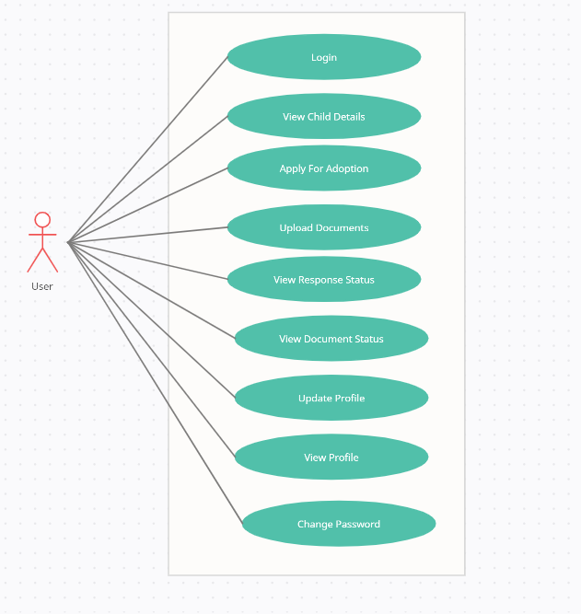

**Fig 1**

**2.1.1 User Account**

The online Child adoption system is developing to facilitate the Children’s. Here the user’s visit the website by registering their details. After the registration process gets over they can enter into the website. They can view the orphanage and child details .Those who want to adopt orphan, they can provide their details such as name, contact number, address and some basic details in registration form.

.

A new user, on the other hand, would either have to

1. register himself with the system by providing personal information or
2. log into the system as a parent.

A parent can only check the details of child’s but cannot delete or add the child.

Availability of child’s always refers to viewing the child’s which we want to adopt.

The system shall present the parent with an adoption form to fill, if they want to proceed with adoption process. They all also have to submit the required documents. The verification of the form will be done at admin side. Which usually will take 10-15days for back ground verification on the basis of given documents. The application shall present the parent with an option to exit from the system at any time during the following processes.

**2.1.2 Admin Account**

Admin can login into the system by providing the login credentials and can see the pending requests regarding the adoption. Admin can also add and delete the child and new admin as well..

After the verification process he will respond back to the parents request by approving the response status. Admin can also view and update their profile .If any parent contact regarding the visiting hours, they can confirm the schedule as well.

He has the accessibility to check how many parents have registered till now. He can also view the count of child and total adoption form till date.

The application shall present the parent with an option to exit from the system at any time during the following processes.

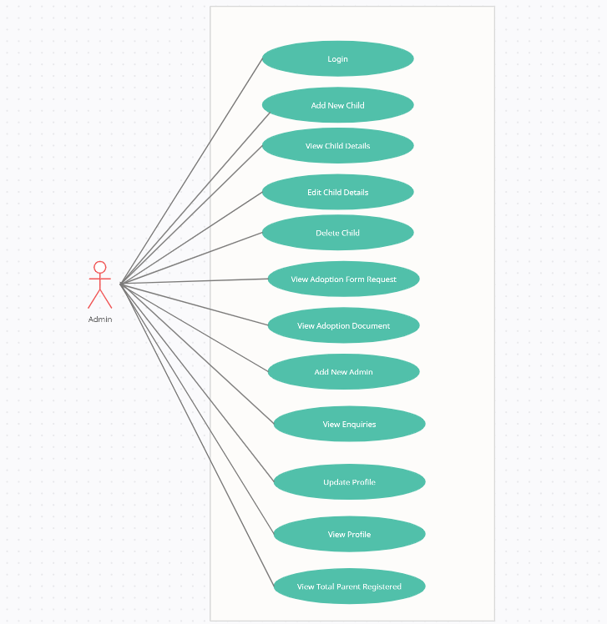

**Fig 2**

**2.1.3 Registration and creation of user profile**

The system shall require a parent to register, in order to carry out any adoption or child related process . It will ask the parent/admin for the following information at the least – a user id, name, phone number, email address, password. Once registration is done the user can login by providing the credentials.

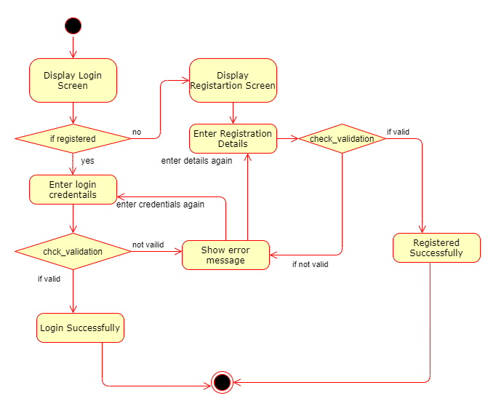

**Fig 3**

**2.1.4 Adoption Process**

After having taken the Parents through the step 2.2, Checking Availability for child’s by viewing child’s Info, The parent can fill the adoption form if they wish to adopt the child. If yes, and

1. If the Parent is already a registered user, and if he/she has logged on already, he/she can fill the adoption form and upload the required documents.

The request will be sent to admin along with the details.

1. The admin will see the request and approve the request and send feedback to the parents.
2. This whole process will take 10-15 days of time period as they have to g through certain offline legal formalities. Once everything is verified admin will respond back to the parent’s request.

**2.1.5 Child Details:**

The system shall allow admin to view all child information. After logging him on, he can directly view child by clicking on view child details. He also has the authority to add and delete the child. If any new child comes, his/her details will be uploaded by the admin on the site. Similarly if any child is adopted, admin can update his/her status as adopted. It will the parents to know that the following child is not available for adoption.

* 1. **NON FUNCTIONAL REQUIREMENTS**

**2.2.1 Usability Requirement**

After admin has Login, redirection is given to login page and various options are display to admin such as Parents and children’s details.

**2.2.2 Economical Feasibility**

A project is considered economically feasible when the benefits that will accrue to the broad community are greater than the cost of undertaking the project. Economic feasibility defines all economic aspects related to our project. In economic feasibility we study the project thoroughly and estimate a cost of the project. In this cost we include everything such as salary of employees throughout the project. If we need any specific tool for the project then cost of that tool is also considered. When all the aspects have been studied then estimated cost is discussed with the client, and if client agrees to pay accordingly to our requirement then the project is said to be economically feasible. My project “Adoption System” is economically feasible as the software which I am using are freely available in the market.

**2.2.3 Security Techniques**

The complete control of the project is under the hands of authorized person who has the password to access this project and illegal access is not supposed to deal with. All the control is under the administrator and the

other members have the rights to just see the records not to change any transaction or entry.

**2.2.4 Other Requirements:**

* **Hardware Interfaces**

The “Child Adoption System” is expected to function on Intel PIII 900 MHz Processor equivalent or above, 128 MB RAM, 4 GB HDD.

* **Software Interfaces**

The “Child Adoption System” shall work on MS Windows operating systems family (MS Windows 98, MS Windows NT Workstation, MS Windows 2000, MS Windows XP). It configures to work with MYSQL database. This System works on Apache Tomcat server. It uses browser IE 5.0 & above. It uses IIS 5.0 server.

**3. DESIGN**

**3.1 Database Design**

The following table structures depict the database design.

# Table1: Users

|  |  |  |  |  |
| --- | --- | --- | --- | --- |
| **Key Type/ Constraint** | **Column Name** | **Data Type** | **Length** | **Allow Null (1=Yes;0=No)** |
| 3 | id | integer | 4 | 0 |
| 0 | email | varchar | 50 | 1 |
| 0 | is_active | boolean | 4 | 0 |
| 0 | mob_number | integer | 4 | 1 |
| 0 | name | varchar | 50 | 1 |
| 0 | password | varchar | 50 | 0 |
| 0 | role | varchar | 50 | 1 |

## **Table2: _Adoption Form**

|  |  |  |  |  |  |  |  |  |
| --- | --- | --- | --- | --- | --- | --- | --- | --- |
| **Key Type/ Constraint** | **Column Name** | | **Data Type** | | **Length** | | **Allow Null (1=Yes;0=No)** | |
| 3 | form_no | | integer | | 4 | | 0 | |
| 0 | adoption_reason | | varchar | | 100 | | 1 | |
| 0 | annual_income | | double | | 8 | | 1 | |
| 0 | applicant_gender | | varchar | | 50 | | 1 | |
| 0 | biological_children | | varchar | | 50 | | 1 | |
| 0 | child_id | | integer | | 4 | | 1 | |
| 0 | company_details | | varchar | | 70 | | 1 | |
| 0 | | is_active | | boolean | | 1 | | 0 | |
| 0 | | nationality | | varchar | | 50 | | 1 | |
| 0 | | occupation | | varchar | | 50 | | 1 | |
| 0 | | pancard | | varchar | | 50 | | 0 | |
| 0 | | permanent_address | | varchar | | 50 | | 1 | |
| 0 | | qualification | | varchar | | 50 | | 1 | |
| 0 | | response | | varchar | | 50 | | 1 | |
| 0 | | spouse_gender | | varchar | | 50 | | 1 | |
| 0 | | spouse_name | | varchar | | 50 | | 1 | |
| 0 | | user_id | | integer | | 4 | | 0 | |

**Table3: ContactUs**

|  |  |  |  |  |
| --- | --- | --- | --- | --- |
| **Key Type/ Constraint** | **Column Name** | **Data Type** | **Length** | **Allow Null (1=Yes;0=No)** |
| 3 | serial_id | integer | 4 | 0 |
| 0 | user_email | varchar | 255 | 1 |
| 0 | user_message | varchar | 255 | 1 |
| 0 | user_name | varchar | 255 | 1 |

### Table4: Document Master

|  |  |  |  |  |
| --- | --- | --- | --- | --- |
| **Key Type/ Constraint** | **Column Name** | **Data Type** | **Length** | **Allow Null (1=Yes;0=No)** |
| 3 | document_id | integer | 4 | 0 |
| 0 | response | varchar | 50 | 1 |
| 0 | address_proof | varchar | 150 | 1 |
| 0 | identity_proof | varchar | 150 | 1 |
| 0 | income_proof | varchar | 150 | 1 |
| 0 | nationality_certificate | varchar | 150 | 1 |
| 0 | non_criminal_certificate | varchar | 150 | 1 |
| 0 | user_id | integer | 4 | 0 |

# Table5: Child Details

|  |  |  |  |  |
| --- | --- | --- | --- | --- |
| **Key Type/ Constraint** | **Column Name** | **Data Type** | **Length** | **Allow Null (1=Yes;0=No)** |
| 3 | child_id | integer | 4 | 0 |
| 0 | age | integer | 4 | 0 |
| 0 | blood_group | varchar | 4 | 1 |
| 0 | colour_complexity | varchar | 50 | 1 |
| 0 | deficiency | varchar | 50 | 1 |
| 0 | education | varchar | 50 | 1 |
| 0 | gender | varchar | 50 | 1 |
| 0 | image | varchar | 100 | 1 |
| 0 | medical_history | varchar | 50 | 1 |
| 0 | name | varchar | 50 | 1 |
| 0 | other | varchar | 100 | 1 |
| 0 | status | varchar | 50 | 1 |
| 0 | user_id | integer | 4 | 0 |

**E-R Diagram, Dataflow diagram and Class Diagram:**

Go to Appendix A

**4. CODING STANDARDS IMPLEMENTED**

### Naming and Capitalization

Below summarizes the naming recommendations for identifiers in Pascal casing is used mainly (i.e. capitalize first letter of each word) with camel casing (capitalize each word except for the first one) being used in certain circumstances.

|  |  |  |  |
| --- | --- | --- | --- |
| **Identifier** | **Case** | **Examples** | **Additional Notes** |
| Class | Pascal | Person, BankVault, SMSMessage, Dept | Class names should be based on "objects" or "real things" and should generally be **nouns**. No ‘_’ signs allowed. Do not use type prefixes like ‘C’ for class. |
| Method | Camel | getDetails, updateStore | Methods should use **verbs** or verb phrases. |
| Parameter | Camel | personName, bankCode | Use descriptive parameter names. Parameter names should be descriptive enough that the name of the parameter and its type can be used to determine its meaning in most scenarios. |
| Interface | Pascal with "I" prefix | Disposable | Do not use the ‘_’ sign |
| Property | Pascal | ForeColor, BackColor | Use a noun or noun phrase to name properties. |
| Associated private member variable | _camelCase | _foreColor, _backColor | Use underscore camel casing for the private member variables |
| Exception Class | Pascal with "Exception" suffix | WebException, |  |

### Comments

* Comment each type, each non-public type member, and each region declaration.
* Use end-line comments only on variable declaration lines. End-line comments are comments that follow code on a single line.
* Separate comments from comment delimiters (apostrophe) or // with one space.
* Begin the comment text with an uppercase letter.
* End the comment with a period.
* Explain the code; do not repeat it.

**5. TEST REPORT**

**Another group called Linux did the testing and the report of the testing is given hereunder.**

**5.1 GENERAL TESTING:**

|  |  |  |  |  |
| --- | --- | --- | --- | --- |
| **SR-NO** | **TEST CASE** | **EXPECTED RESULT** | **ACTUAL RESULT** | **ERROR MESSAGE** |
| 1 | Register Page | Redirected to Next page | OK | Nothing |
| 2 | Login Page | Pop-up will come | Ok | Please enter username and password again . |
| 3 | Change Password | Only users password will be changed | Ok | 6 to 20 characters which contain at least one numeric digit, one uppercase and one lowercase letter. |
| 4 | View Profile | Give user profile details | Ok | Nothing |
| 5 | View Child Details | Give all child details | Ok | Nothing |
| 6 | Fill Adoption Form | All the fields should be filled for submission | Ok | Nothing |
| 7 | Upload Documents | All the documents fields should be uploaded for submission | Ok | Please upload “Document Name” |
| 8 | View Response Status | Check for approved status | Ok | Nothing |
| 9 | Update Profile | User details will be updated | Ok | All fields mandatory |
| 10 | Add Childs | All the fields should be filled for submission | Ok | All fields mandatory |
| 11 | View Adoption Form Request | Get all adoption form request and send response | Ok | Nothing |
| 12 | View Adoption Document Request | Get all adoption documents request and send response | Ok | Nothing |
| 13 | Edit Child | Child details will be updated | Ok | All fields mandatory |
| 14 | Delete Child | Child will be deleted | Ok | Nothing |
| 15 | Add New Admin | New admin created by current admin | Ok | All fields mandatory |
| 16 | View Enquiries | Get all enquiries | Ok | Nothing |
| 17 | Total Adoption form Request | Get total number of adoption form request | Ok | Nothing |
| 18 | Total Childs | Get total number of child’s | Ok | Nothing |
| 19 | Total Parent Registered | Get total number of parents | Ok | Nothing |
| 20 | Send Enquiry Message | All the fields should be filled for enquiry | Ok | Nothing |
| 21 | Logout | It will logout from user profile. | Ok | Nothing |

**6. PROJECT MANAGEMENT RELATED STATISTICS**

|  |  |  |  |
| --- | --- | --- | --- |
| **DATE** | **WORK PERFORMED** | ****SLC Phase**** | **Additional Notes** |
| MARCH 16,2022 | Project Allotment and User Requirements Gathering | Feasibility Study | Our team met the Project Mentor Mrs. Prajakta Patil to know the requirements. |
| MARCH 17,2022 | Initial SRS Document Validation  And Team Structure Decided | Requirement Analysis  (Elicitation) | The initial SRS was presented to the client to understand his requirements better |
| MARCH 18,2022 | Designing the use-cases, Class Diagram, Collaboration Diagram, E-R Diagram and User Interfaces | Requirement Analysis &  Design Phase | Database Design completed |
| MARCH 25,2022 | Business Logic Component design Started | Design Phase | Database Design implemented |
| MARCH 25, 2022 –  MARCH 26,2022 | Coding Phase Started | Coding Phase | Login, Registration, Logout and Change Password functionality completed. |
| MARCH 27, 2022 | Implementation of Web Application Started | Coding Phase | Initial home, aboutus page designed. |
| MARCH 28, 2022 | Implementation of Web Application and Backend Continued | Coding Phase | Adoption form, Edit profile functionality completed. |
| MARCH 29, 2022 | Implementation of Web Application Continued | Coding Phase | Document Upload and find document by id functions completed |
| MARCH 30, 2022 | Implementation of Web Application Continued | Coding Phase | Add Child, Show child’s functionality completed. |
| MARCH 31, 2022 | Implementation of Web Application Continued | Coding Phase | Edit child and Delete child functionality completed. |
| APRIL 1, 2022 | Implementation of Web Application Continued | Coding Phase | Add New Admin, Edit Admin Profile functionality completed. |
| APRIL 3, 2022 | Implementation of Web Application Continued | Coding Phase | Count total Adoption form, Parents, Childs functionality completed. |
| APRIL 5, 2022 | Implementation of Web Application Continued | Coding Phase | Get Adoption form request, Documents request and Send Response from Admin side functionality completed. |
| APRIL 7, 2022 | Implementation of Web Application Continued | Coding Phase | Conatus functionality completed. |
| APRIL 8, 2022 | Implementation of Web Application Continued | Coding Phase | Testimonial and Donate Pages completed. |
| APRIL 10, 2022 | After Ensuring Proper Functioning the Required Validations were Implemented | Coding Phase | Module Integration was done by our team. |
| APRIL 12, 2022 | The Errors Found were Removed | Debugging | The Project was complete for submission |
| APRIL 13, 2022 | Documentation Completed |  |  |
| APRIL 16, 2022 | Final Submission of Project |  |  |

Appendix A

Entity Relationship Diagram

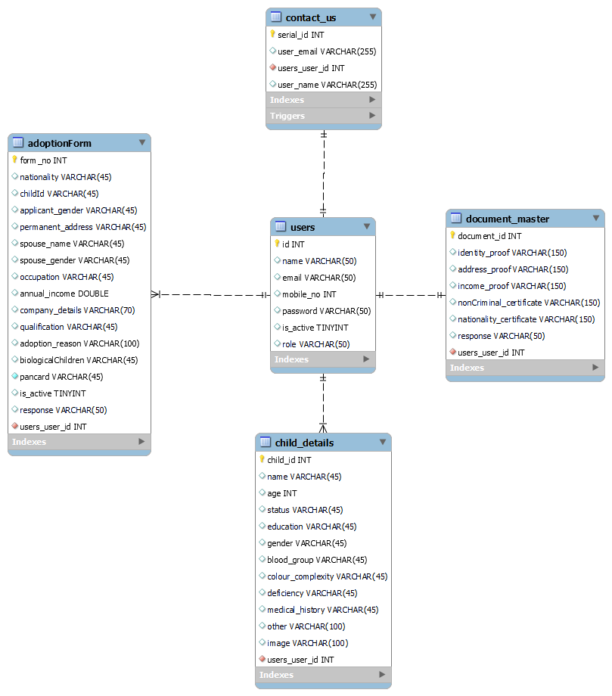

Fig 4

**Data Flow Diagram:**

**Level 0**

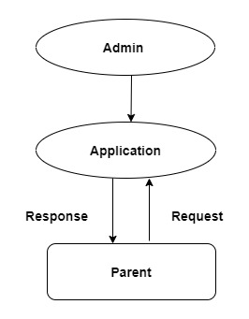

Fig 5

**Level 1(Admin):-**

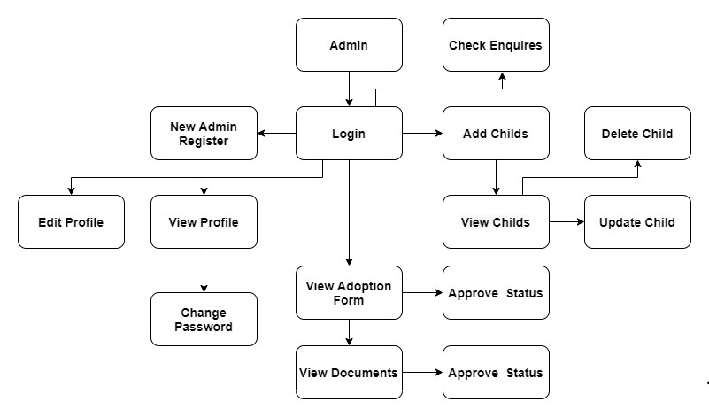

Fig 6

**Level 1(Parent):-**

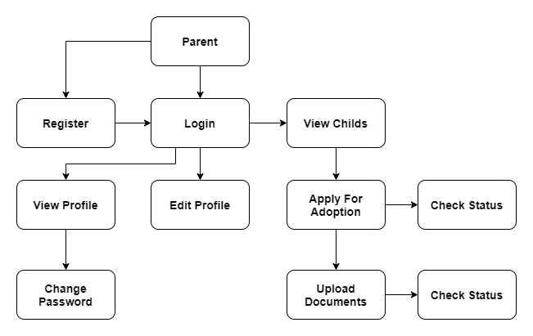

Fig 7

**Class Diagram**

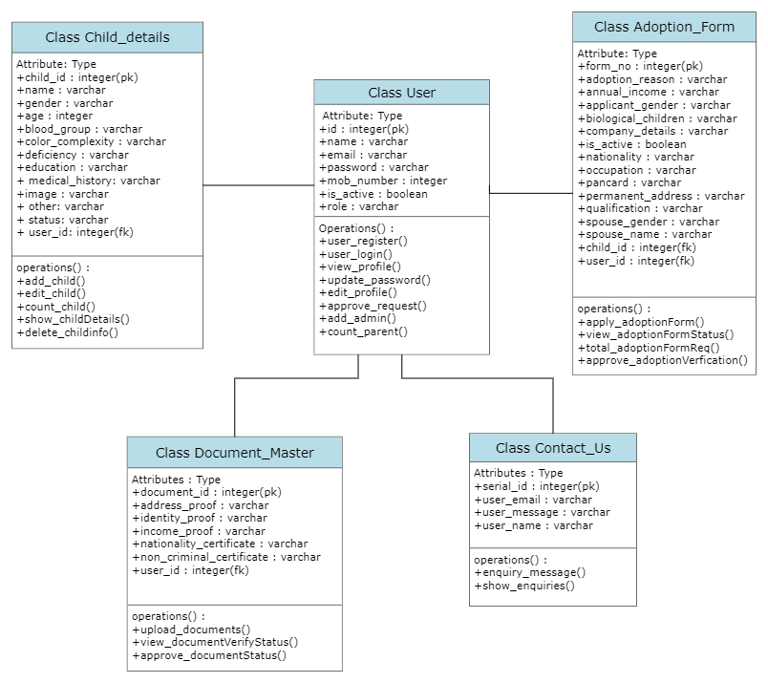

Fig 8

Appendix B

Homepage:

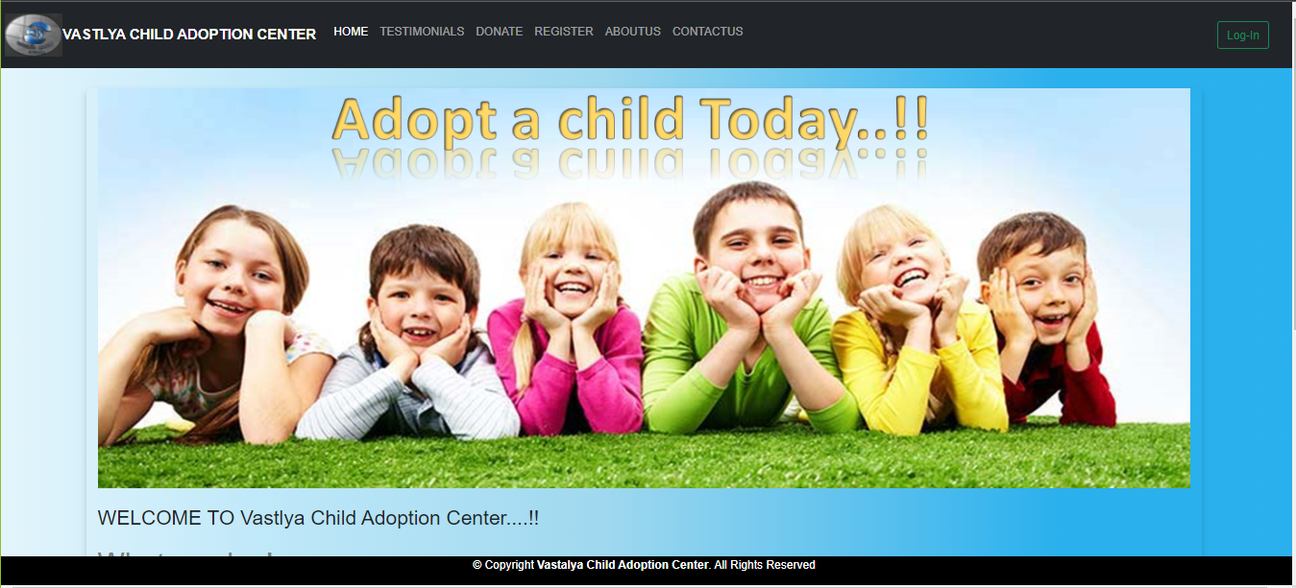

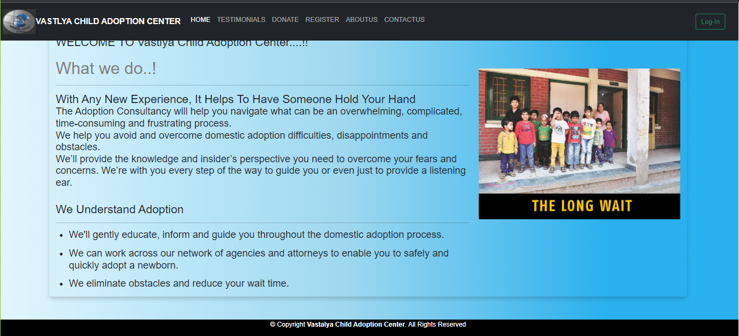

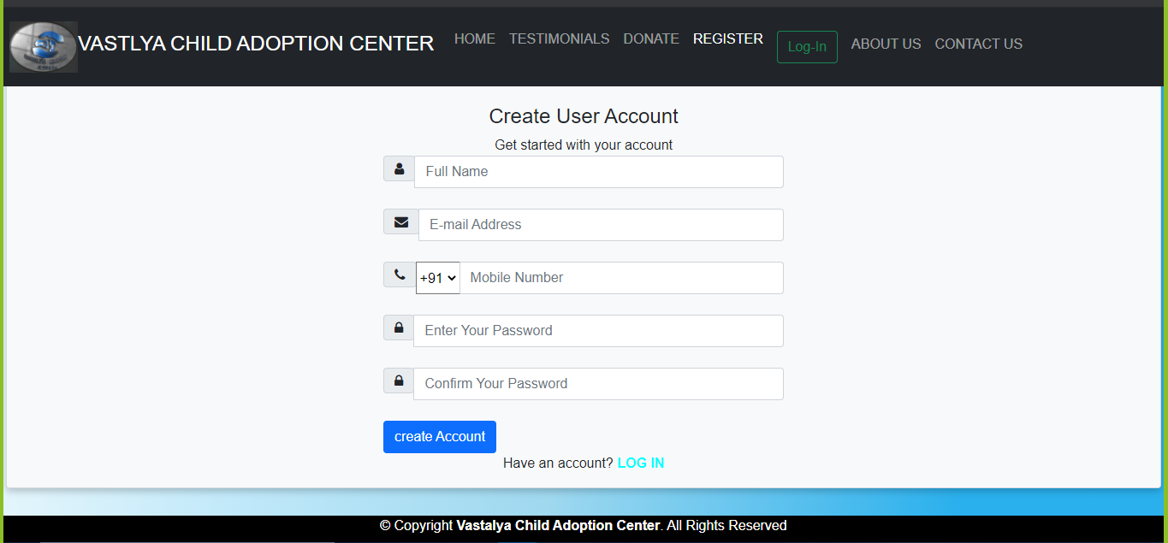User Registration:

Login:

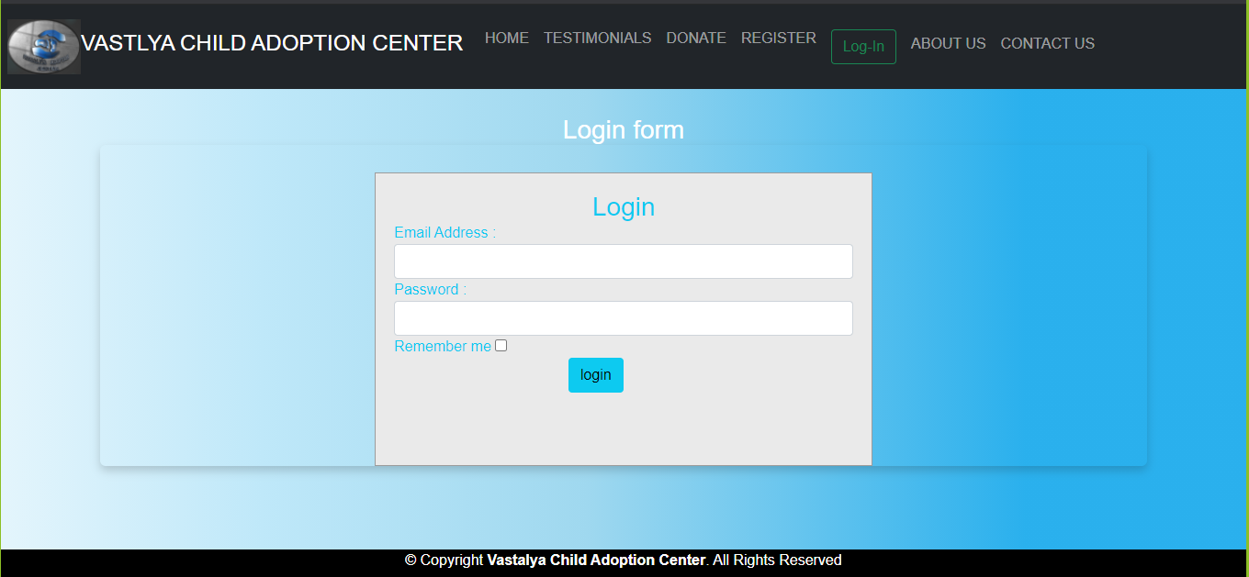

Admin Dashboard:

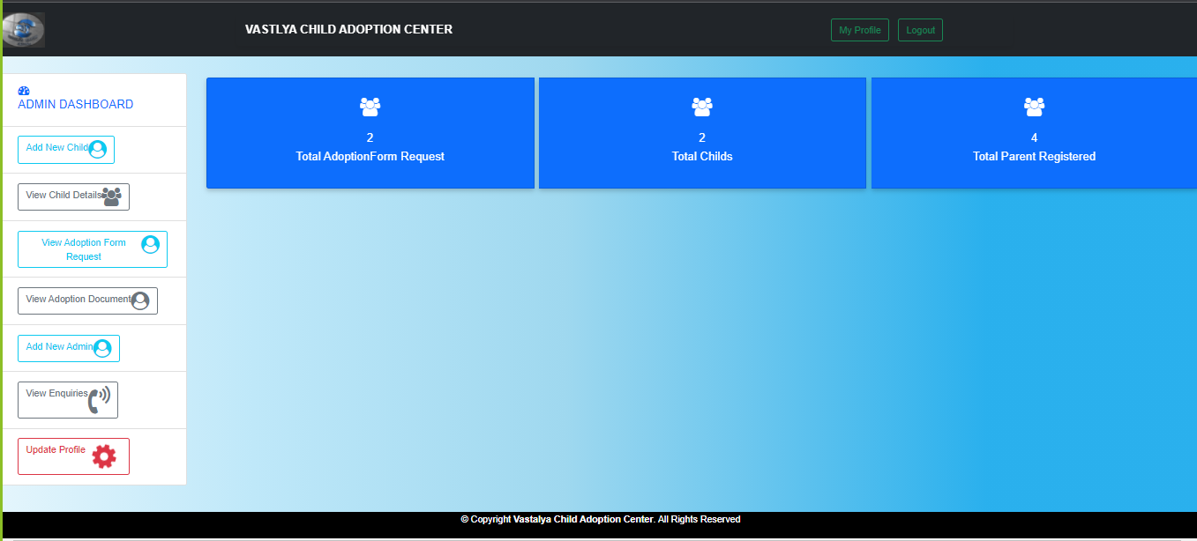

Add Child:

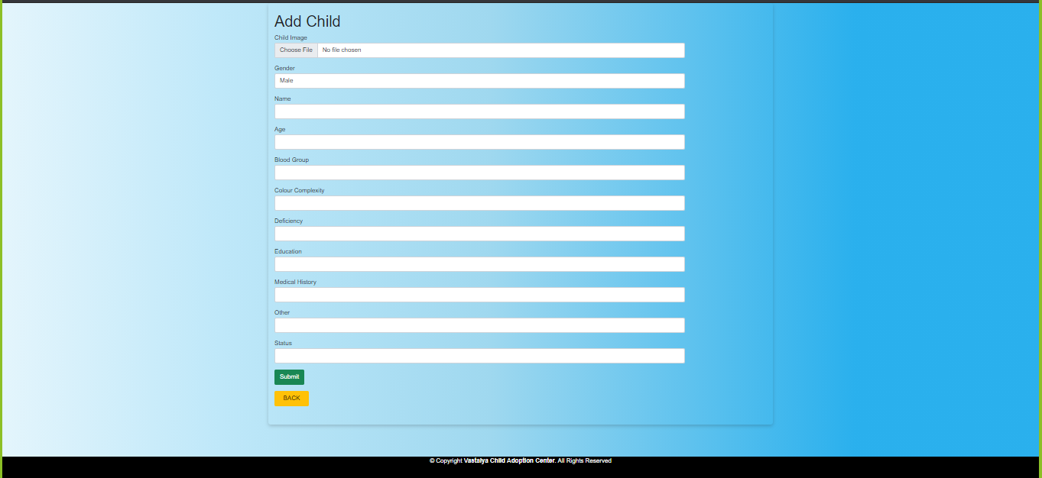

View Child:

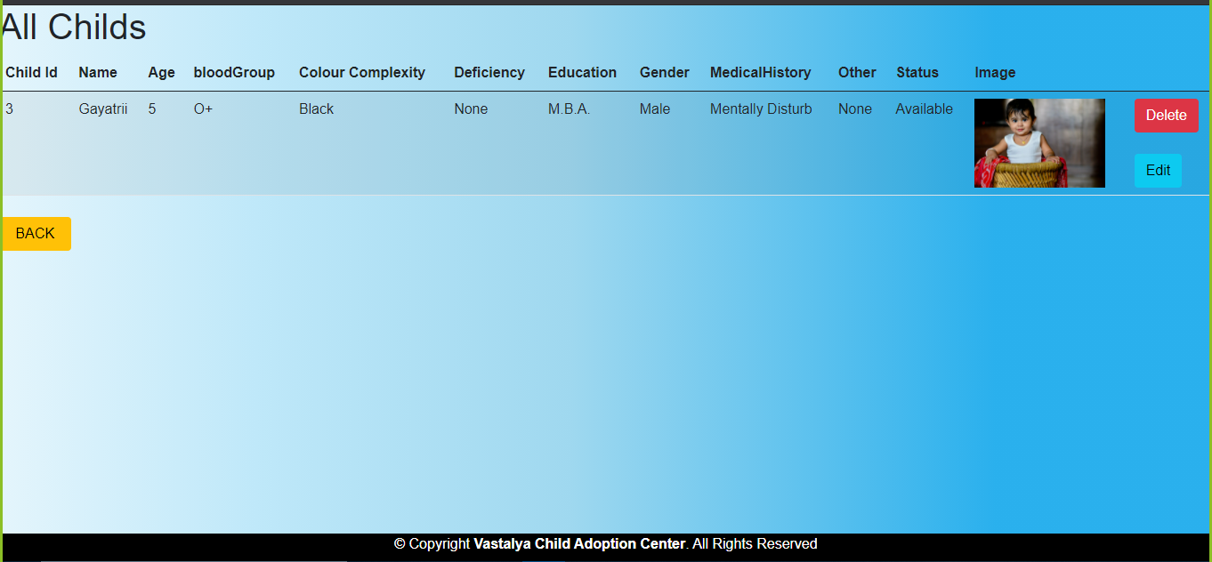

Edit Child:

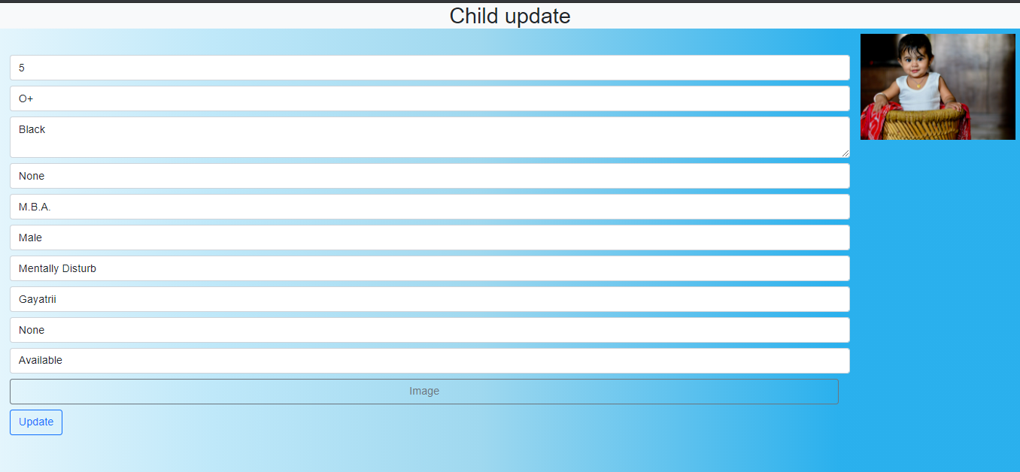

View Adoption Form Request:

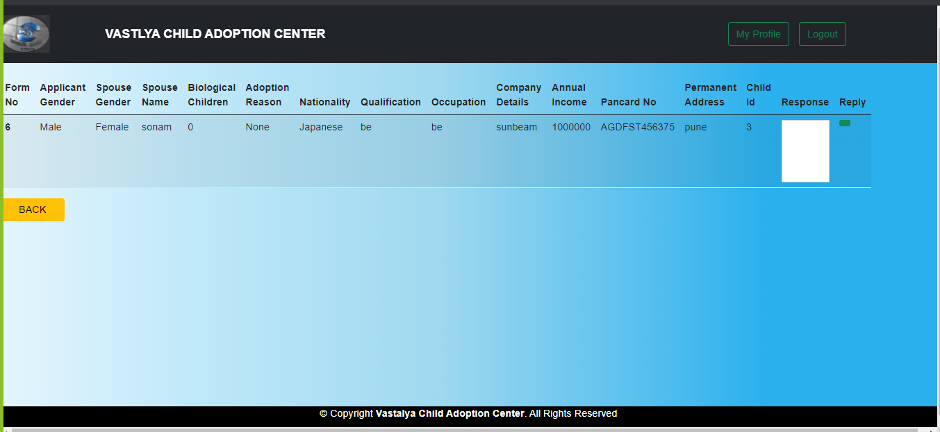

View Adoption Document Request:

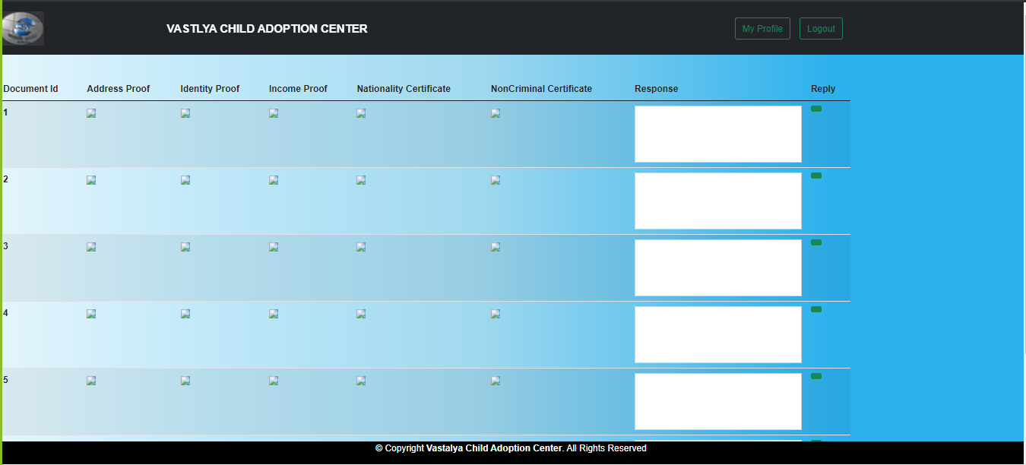

Add New Admin:

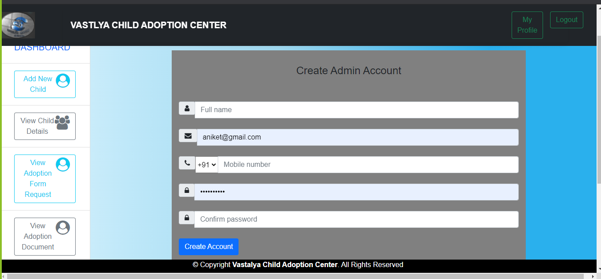

View Enquiry:

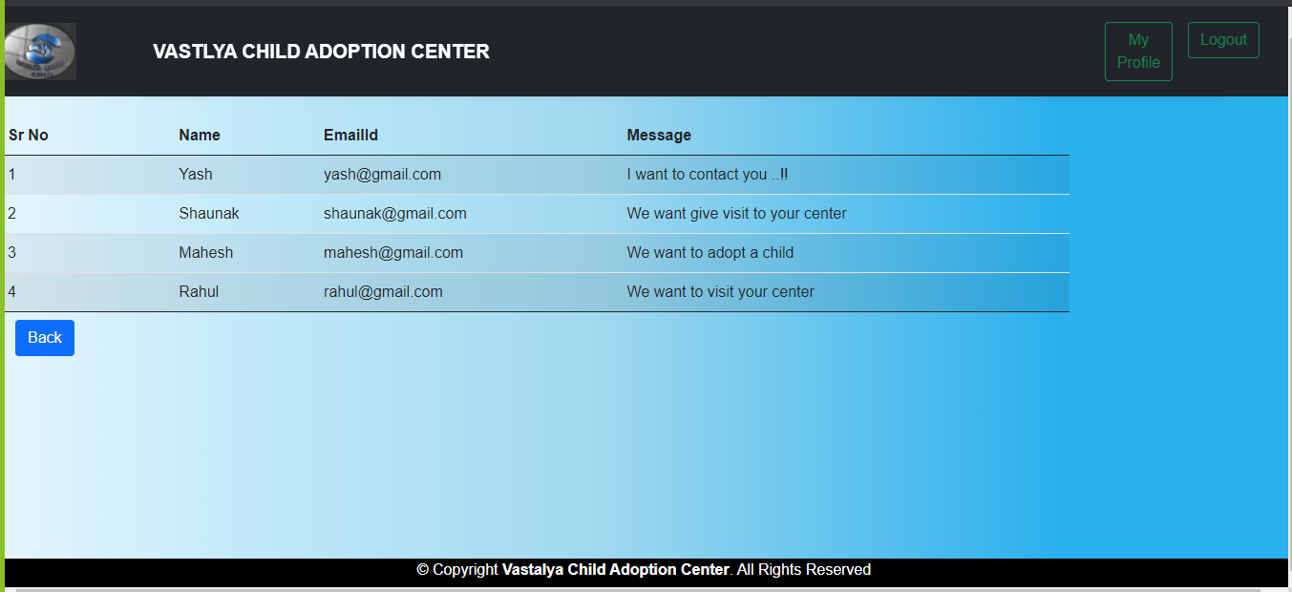

My Profile:

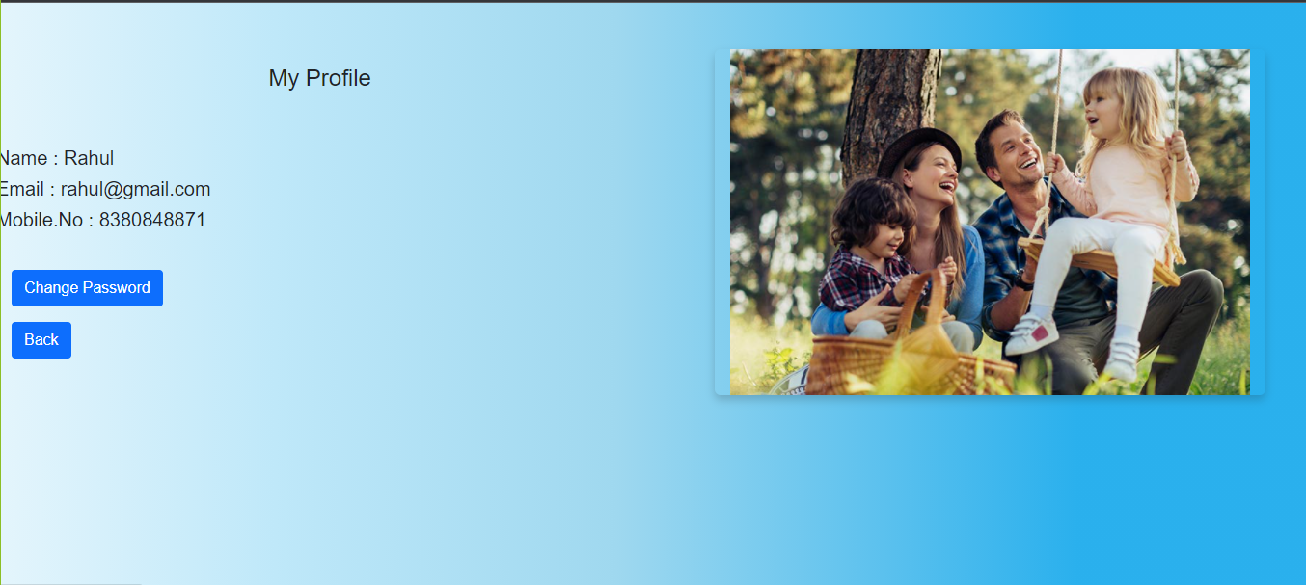

Change Password:

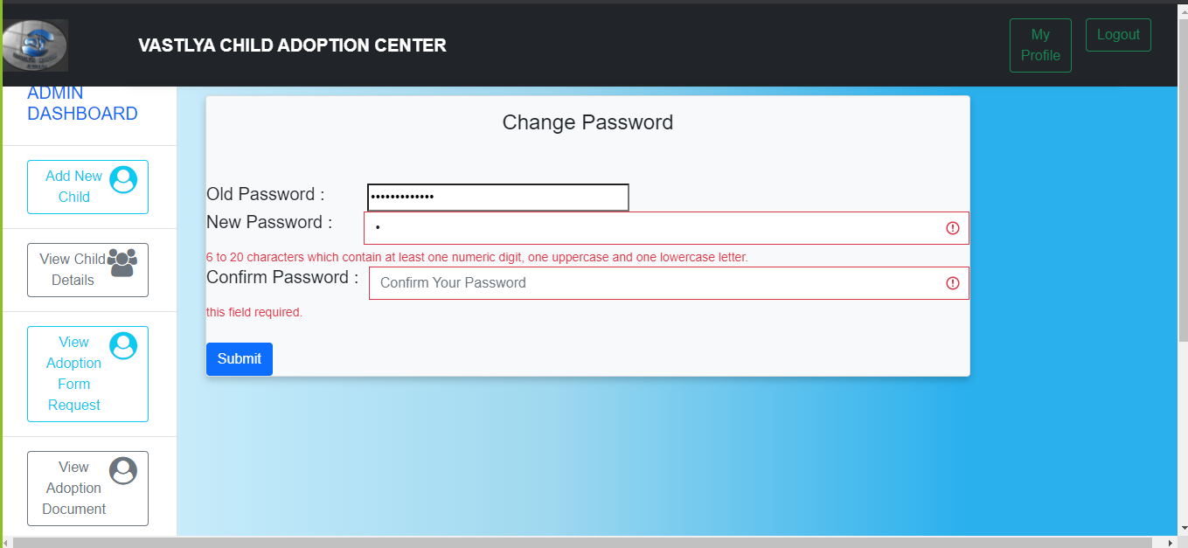

Edit Profile:

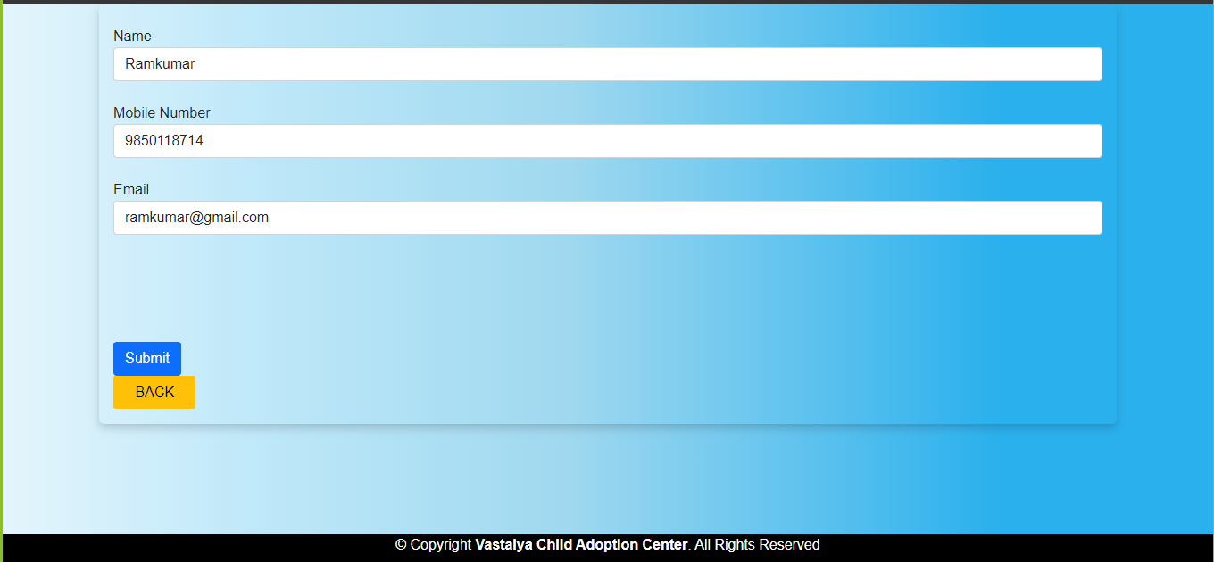

Parent Dashboard:

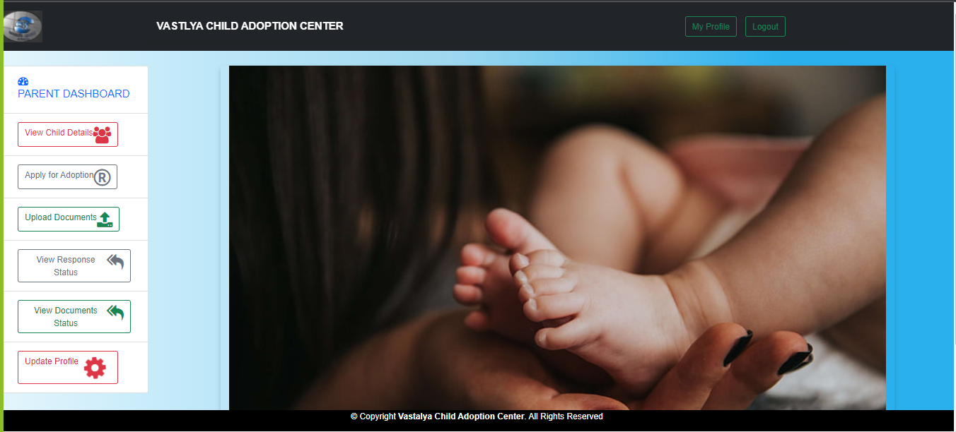

View Child(Parent Side):

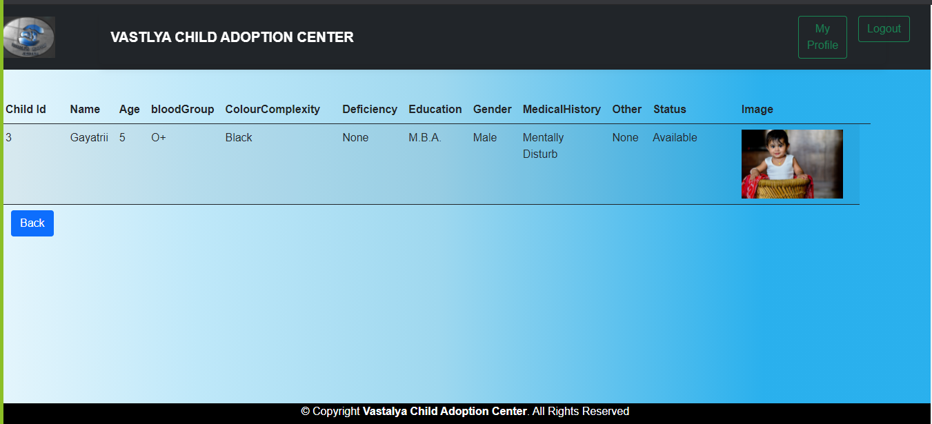

Apply For Adoption:

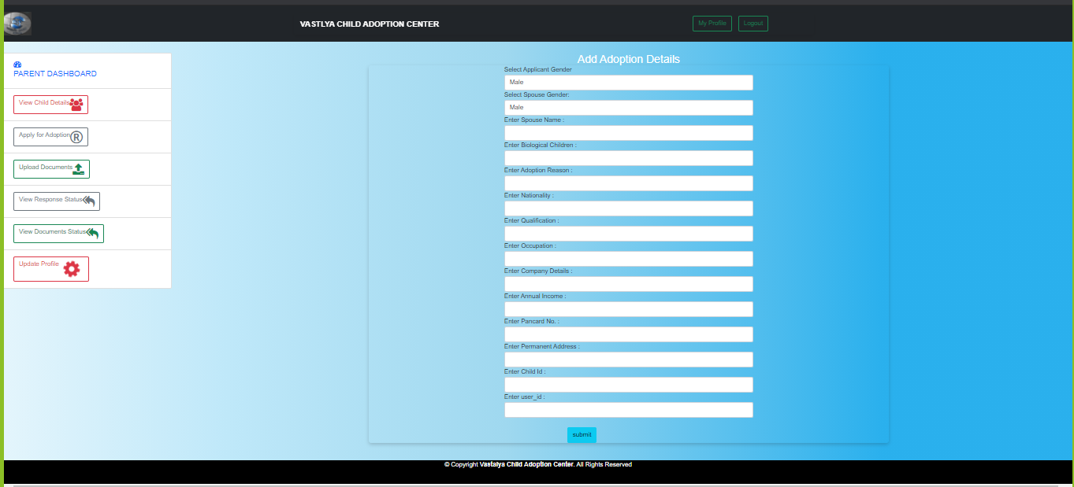

Upload Document:

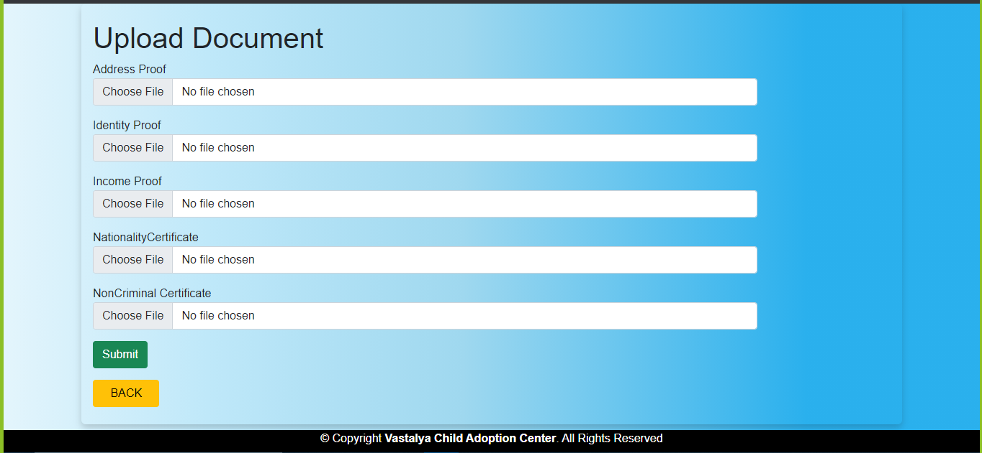

View Response Status:

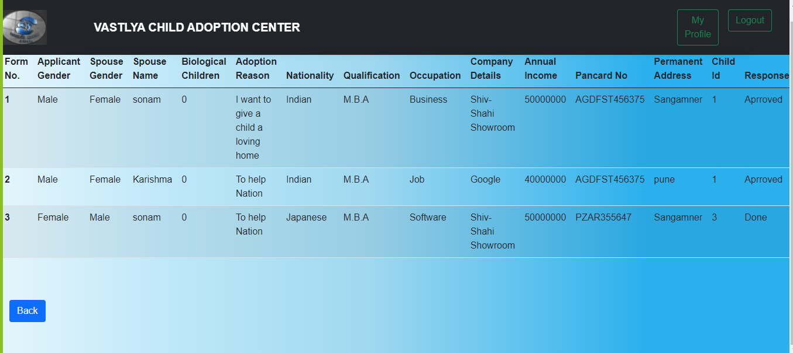

View Document Response Status:

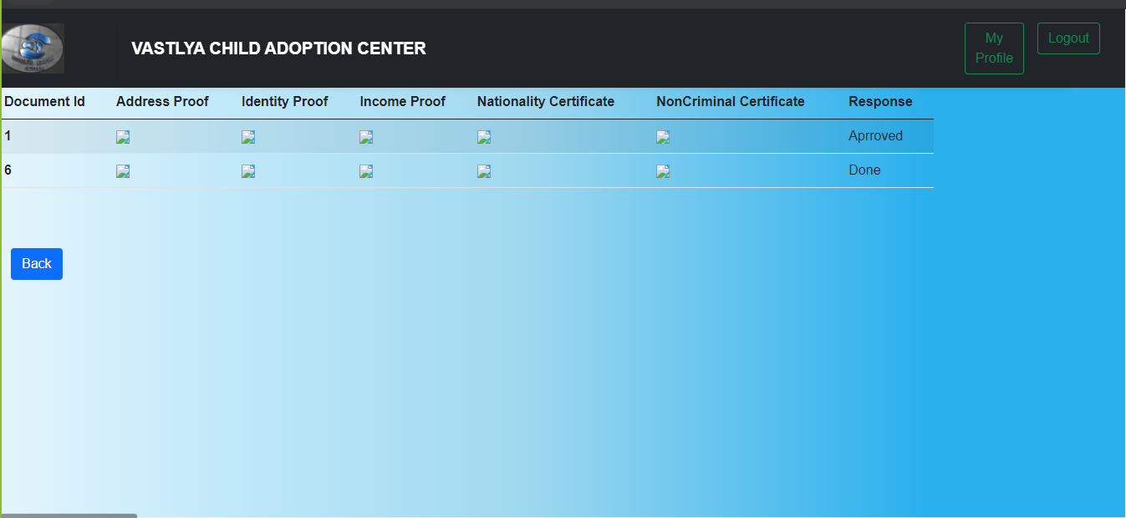

Contact Us:

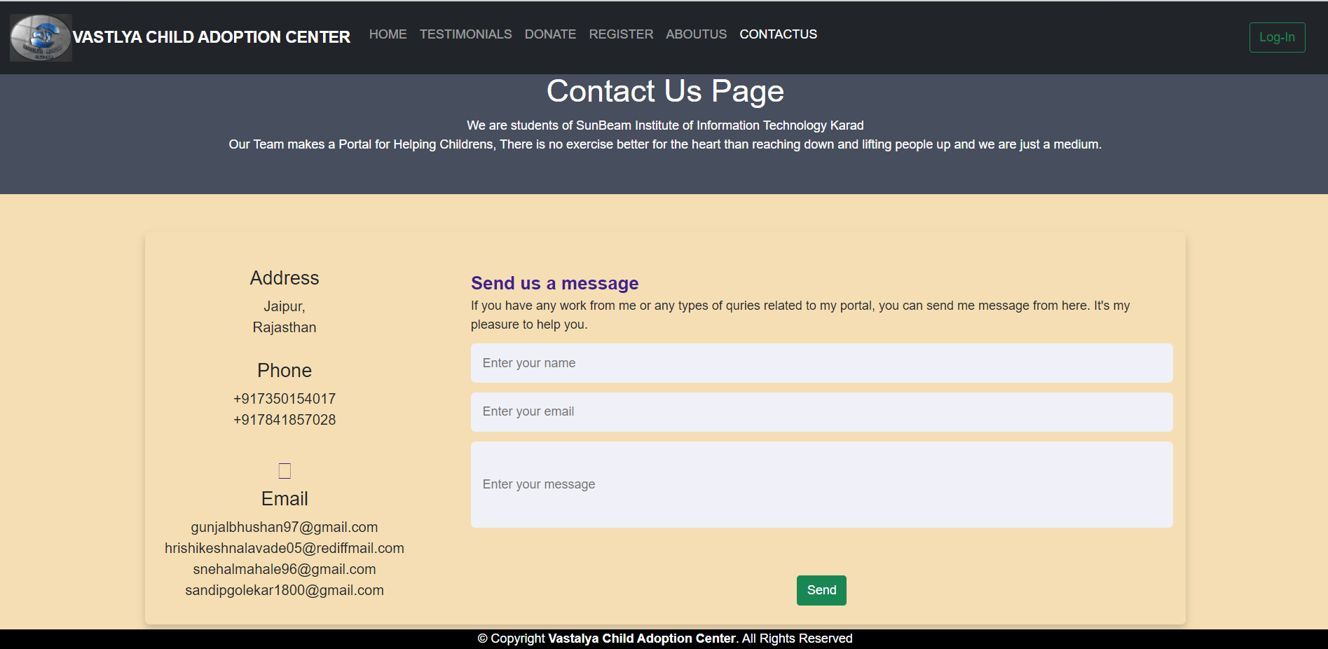

About Us:

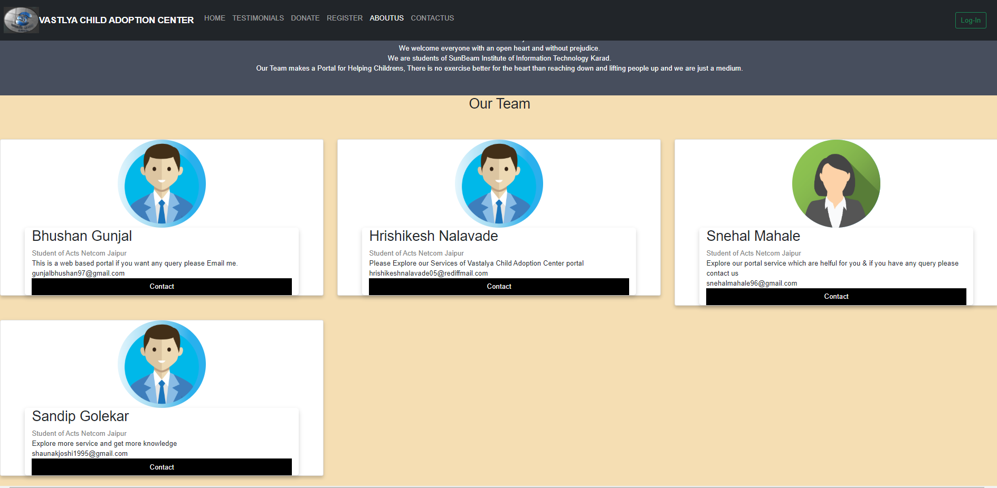

Donate:

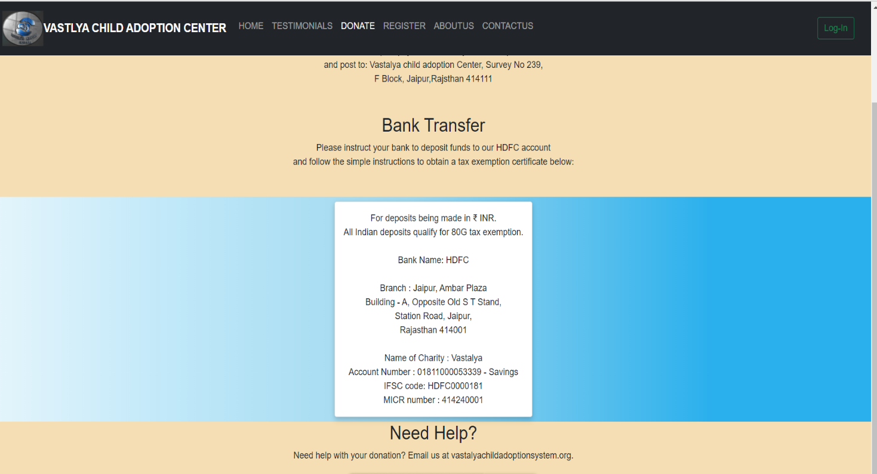

Testimonial:

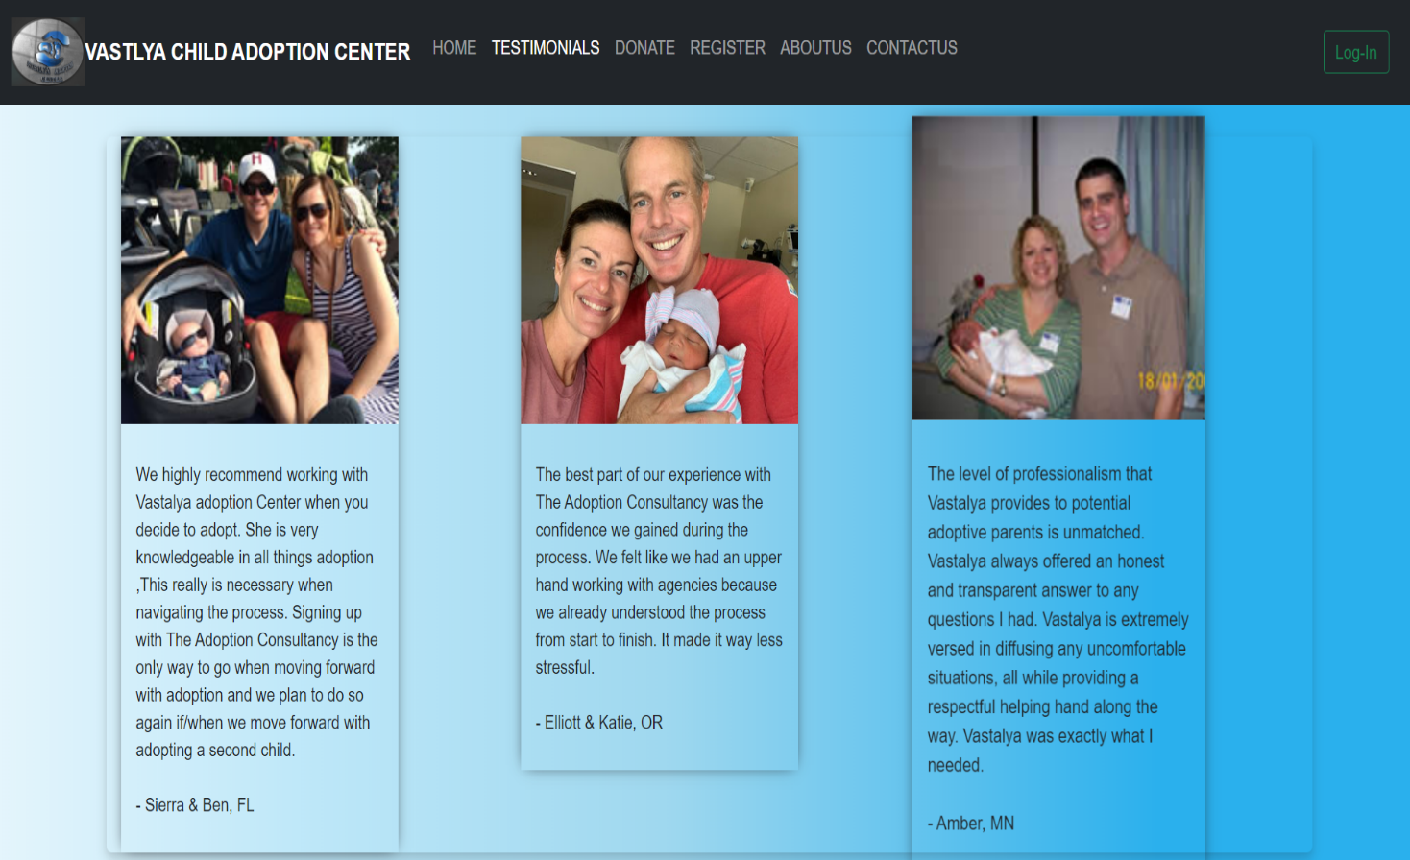

**7.REFERENCES:**

<http://www.google.com>

<https://balashatrust.org/>

<http://cara.nic.in/>

<https://www.snehalaya.org/adoption>

<https://theadoptionconsultancy.com/index.php?gclid=EAIaIQobChMIp8ee77rf8AIVl34rCh2KtgLEEAAYAiAAEgL-oPD_BwE>

http://www.wikipedia.org